Showbie

At Jedburgh Grammar Campus we regularly use Showbie to communicate with parents and carers. Primary pupils add items of work to online portfolios each term and secondary parents have access to their child/children’s full Showbie account.
Each pupil in school has their own Showbie account which parents/carers can connect to through a unique code. Primary year groups also have a parent/carers communication group through which class announcements and updates are shared.
As a school we use the following codes to communicate to pupils and parents/carers on Showbie:
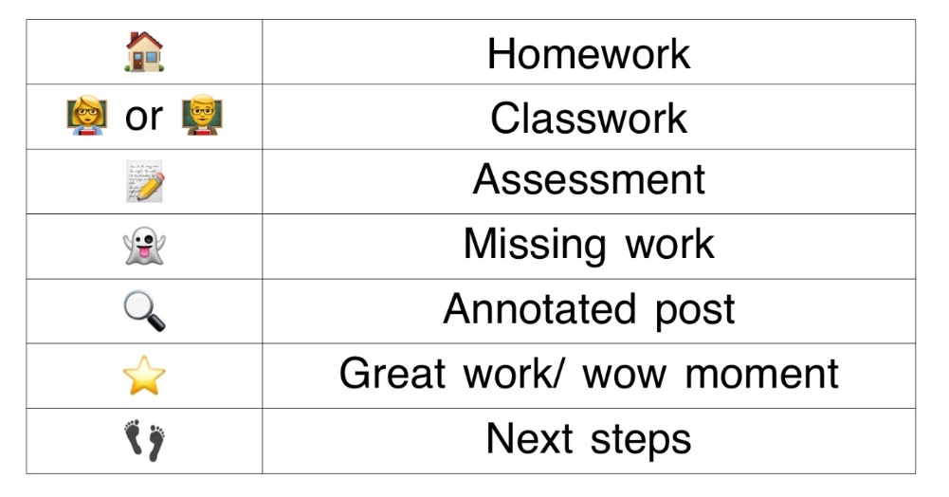

If you would like to connect to your child’s Showbie account, or are having issues with your Showbie account then please email gw18johnstonhamish@glow.sch.uk or gw09seatonkaren@glow.sch.uk and we will be happy to assist you.

